**DA-2**

Structured and Object-Oriented Programming Lab (BCSE102P)

**by:**

**sree lagudu madhu kiran(22BAI1359),**

**K.Parksunnath(22BAI1356)**

CREATED NON STATIC GRAPHICS PROGRAM ON C++ USING THE HEADER FILE GRAHICS.H

WE USED “CODE BLOCKS” FOR WORKING AND EXECUTING THE CODE.

Other included header files of our code

<dos.h> header file was commonly used in conjunction with the Borland Graphics Interface (BGI) library to access low-level DOS functions for graphics programming. It provided functions, structures, and constants to interact with the hardware and system services of the DOS environment.

THE METHODS WE USED IN OUR CODE AND THEIR EXPLAINATIONS.

* gd=DETECT is typically used as a part of the graphics initialization code for the Borland Graphics Interface (BGI). BGI is a graphics library
* Our program initializes the graphics system using initgraph(&gd, &gm, "..\\bgi"), where gd and gm are the graphics driver and graphics mode respectively. It then proceeds to draw various shapes and lines on the screen using **BGI functions** like line, rectangle,circle,ellipse.
* Line: It is used to draw a line segment between two specified points on the screen.

Syntax:

**void line(int x1, int y1, int x2, int y2);**

* x1 and y1 represent the coordinates of the starting point of the line.
* x2 and y2 represent the coordinates of the ending point of the line.

The line() function connects the two points specified by (x1, y1) and (x2, y2) with a straight line segment.

* Circle:

SYNTAX:

**void circle(int x, int y, int radius);**

* x and y represent the coordinates of the center of the circle.
* radius specifies the radius of the circle.

The circle() function draws a circle with the specified center coordinates (x, y) and the specified radius.

* Ellipse:

**Syntax: void ellipse(int x, int y, int start_angle, int end_angle, int x_radius, int y_radius);**

* x and y represent the coordinates of the center of the ellipse.
* start_angle and end_angle specify the starting and ending angle of the ellipse arc, measured in degrees.
* x_radius and y_radius represent the horizontal and vertical radii of the ellipse.

The ellipse() function draws an ellipse with the specified center coordinates (x, y), radii x_radius and y_radius, and an arc from start_angle to end_angle. If start_angle is 0 and end_angle is 360, a complete ellipse is drawn.

* Rectangle:

Syntax: **void rectangle(int left, int top, int right, int bottom);**

* left and top represent the coordinates of the top-left corner of the rectangle.
* right and bottom represent the coordinates of the bottom-right corner of the rectangle.

The rectangle() function draws a rectangle with the specified coordinates for the top-left and bottom-right corners.

* After drawing the graphical elements, the program waits for a key press using getch() and then closes the graphics window using closegraph().

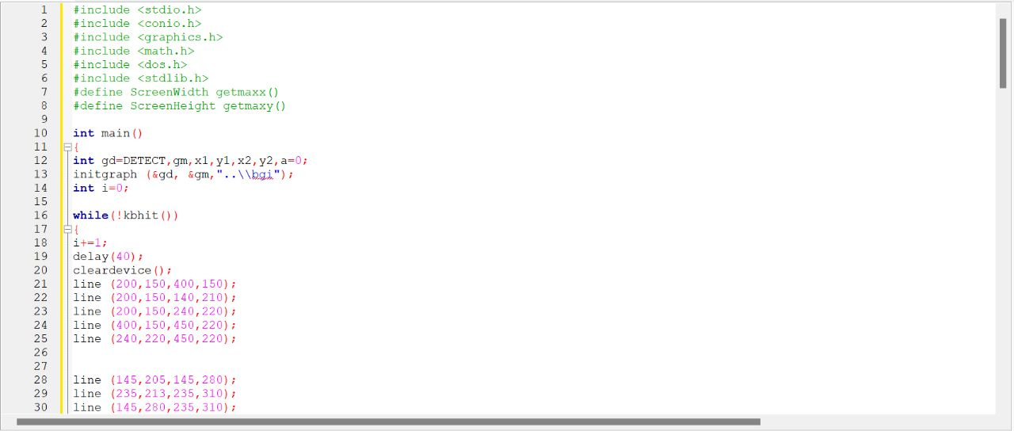

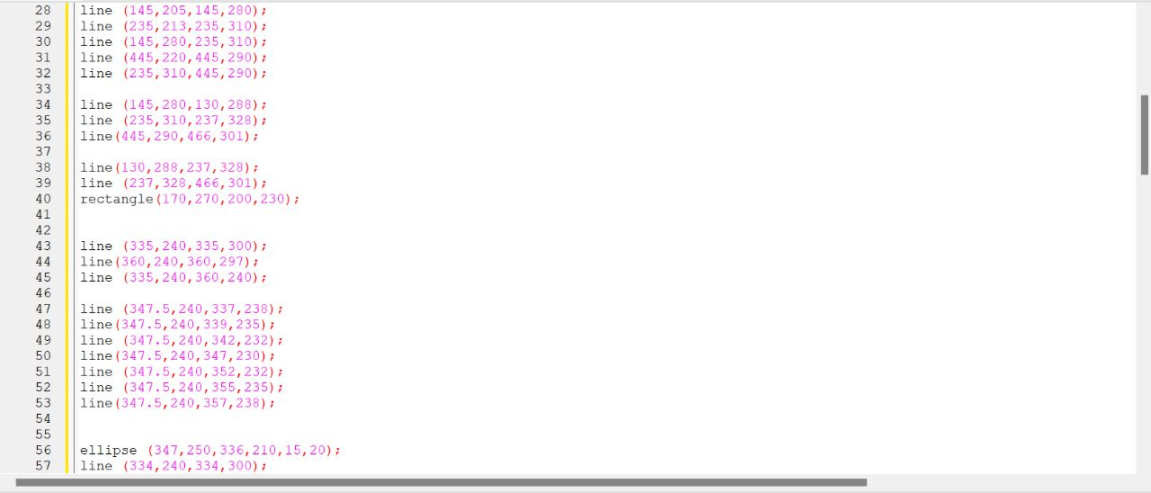

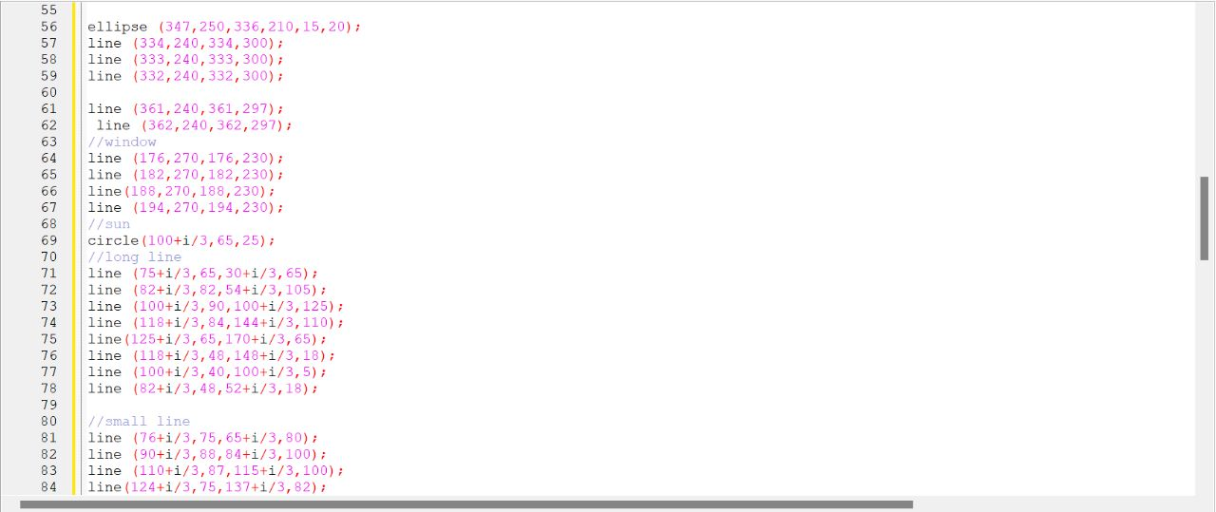

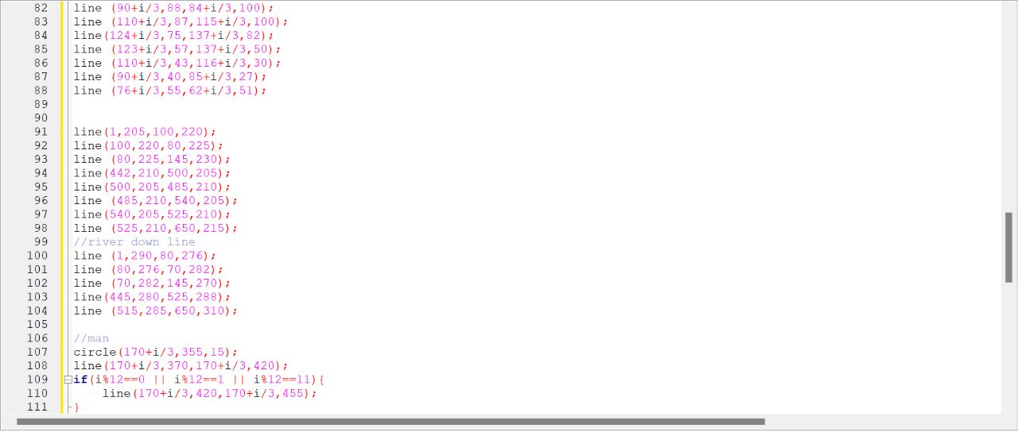

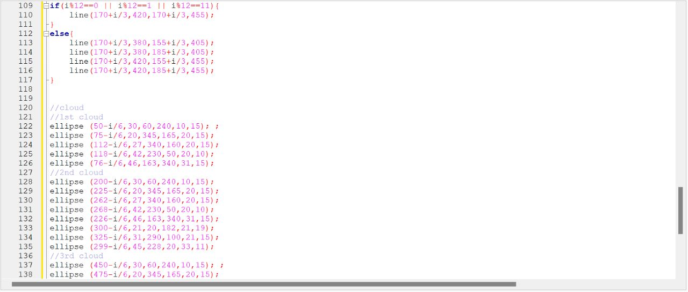

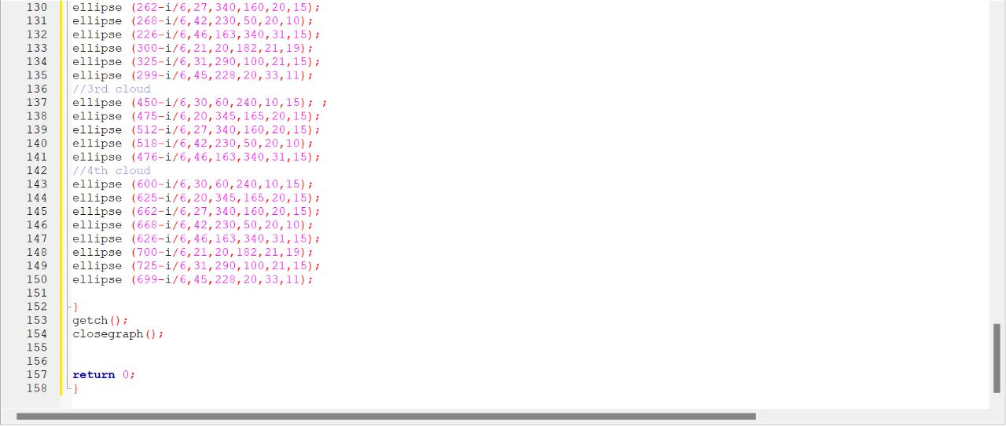

Output screen

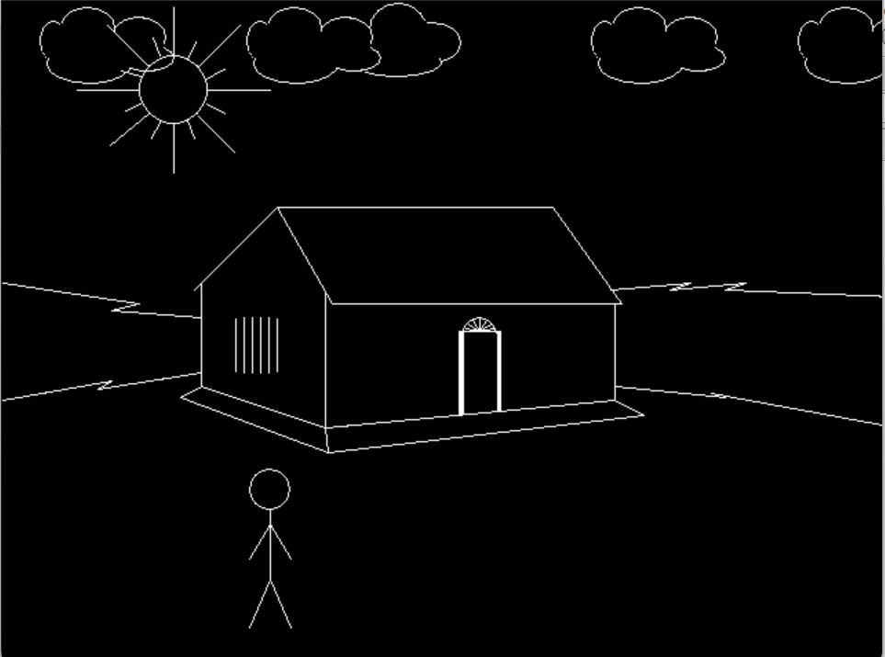

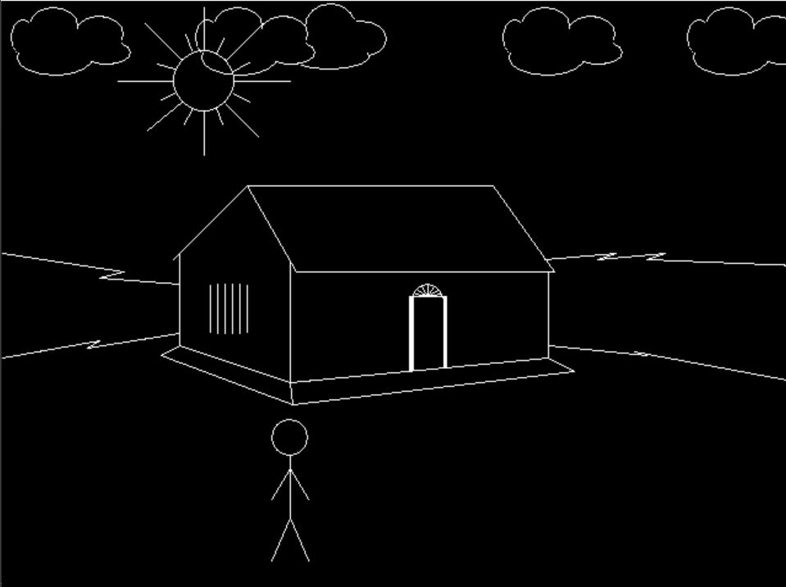

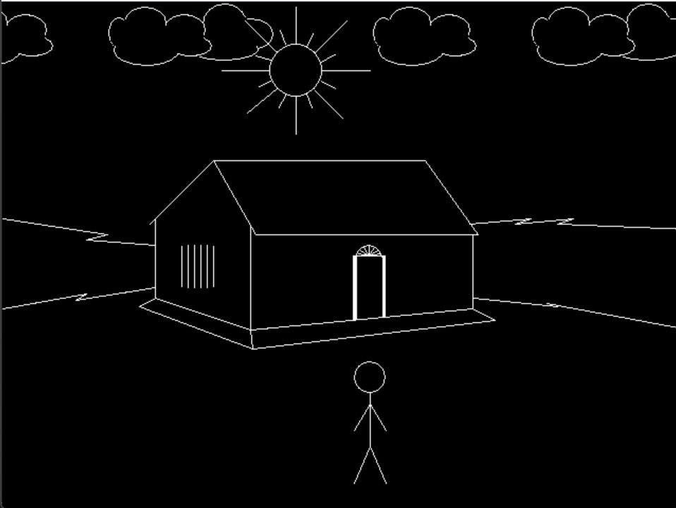

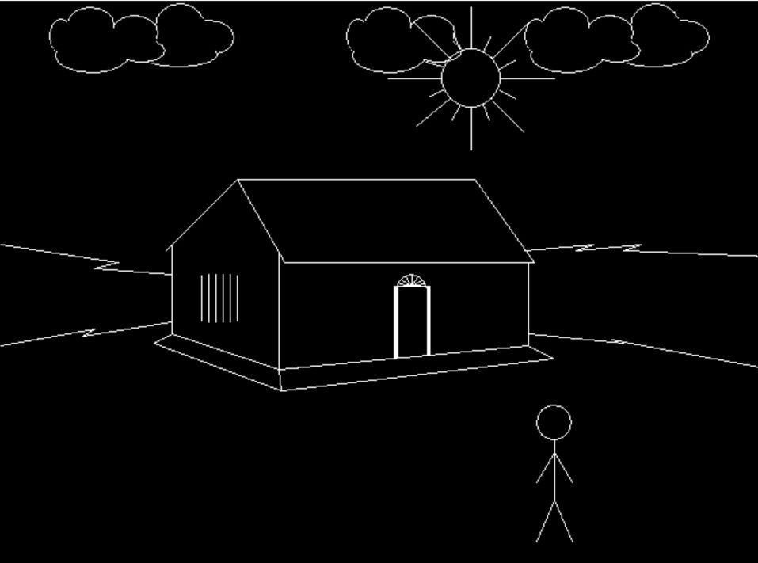

In this program we can observe the movement of the sun the man and the clouds, we done this by iterating different values for the different objects.